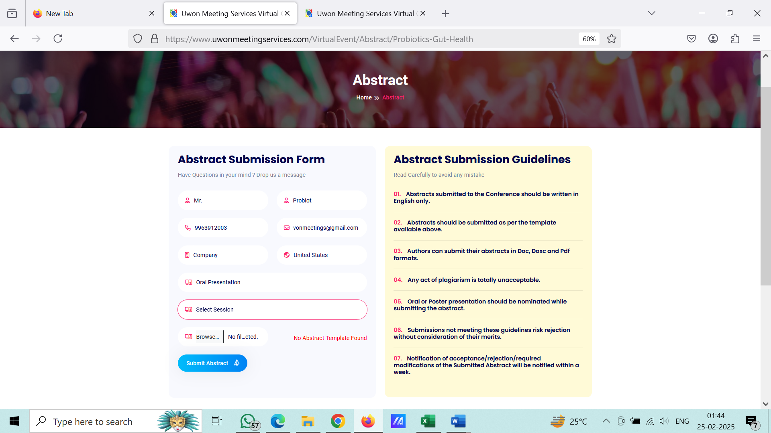

I have updated the sessions at the admin page, but there are no sessions to select while submitting the Abstract. I am getting the session selection option with Child-Adolescent-Mental-Health but not with Probiotics-Gut-Health.

No template or the format to download for the Submitter.

I have submitted the Abstract, but no confirmation message on the screen after submission. Please display it.

Where exactly the submitted Abstracts will be found in Admin. Please create a tab for Abstract lists as for the rest.

Email confirmation to the submitter email.

Please enable mobile numbers with country code.

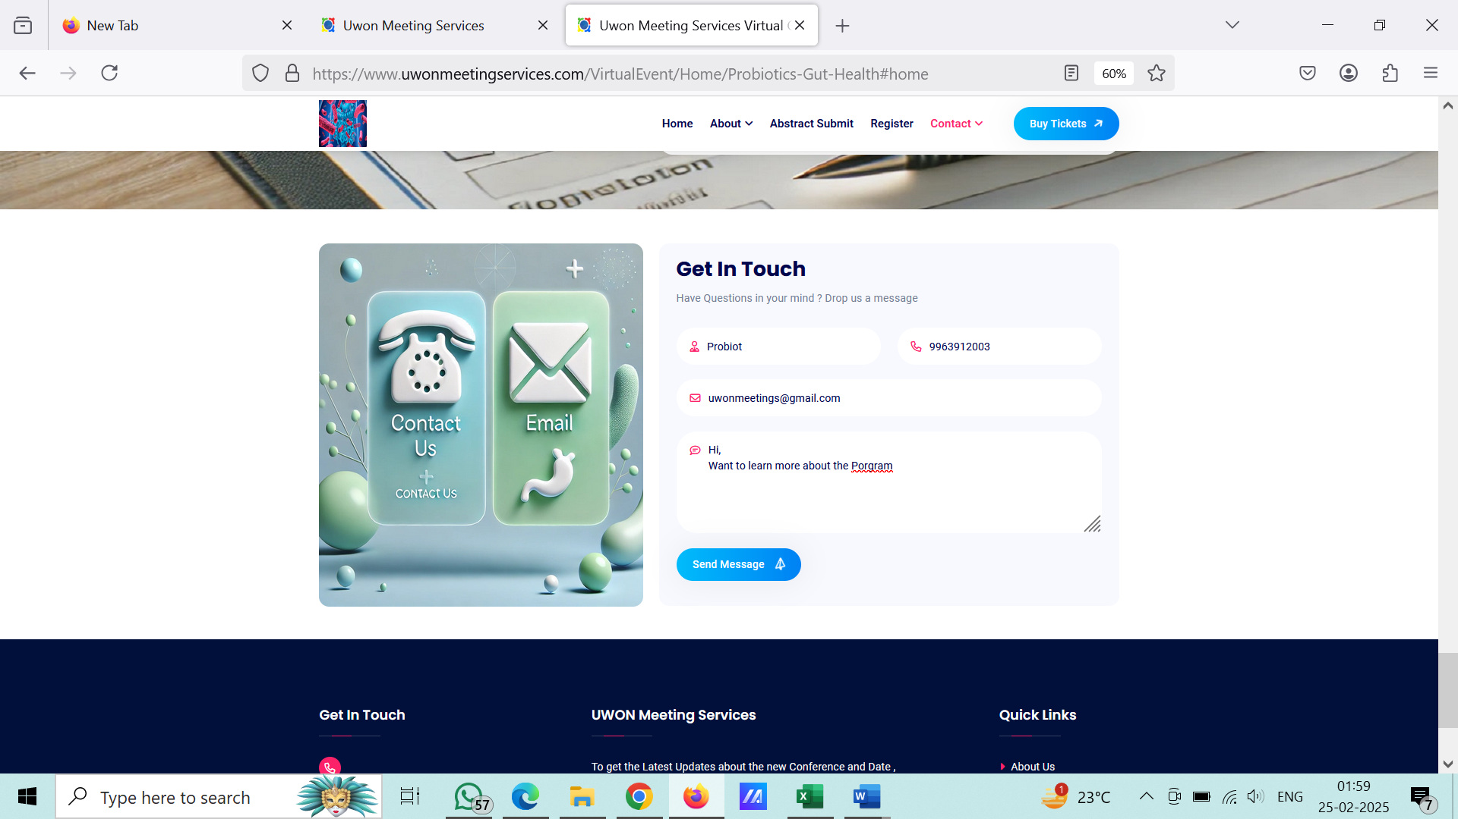

Receiving the message at the admin page under Enquiry Lists

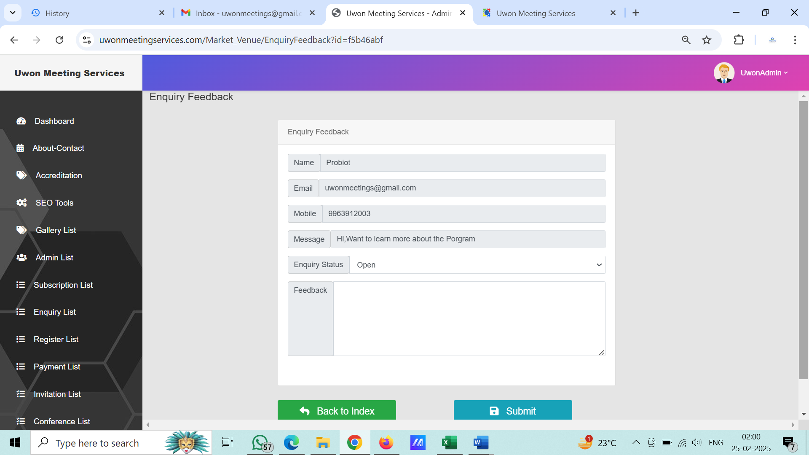

Please enable mobile/phone no with country codes

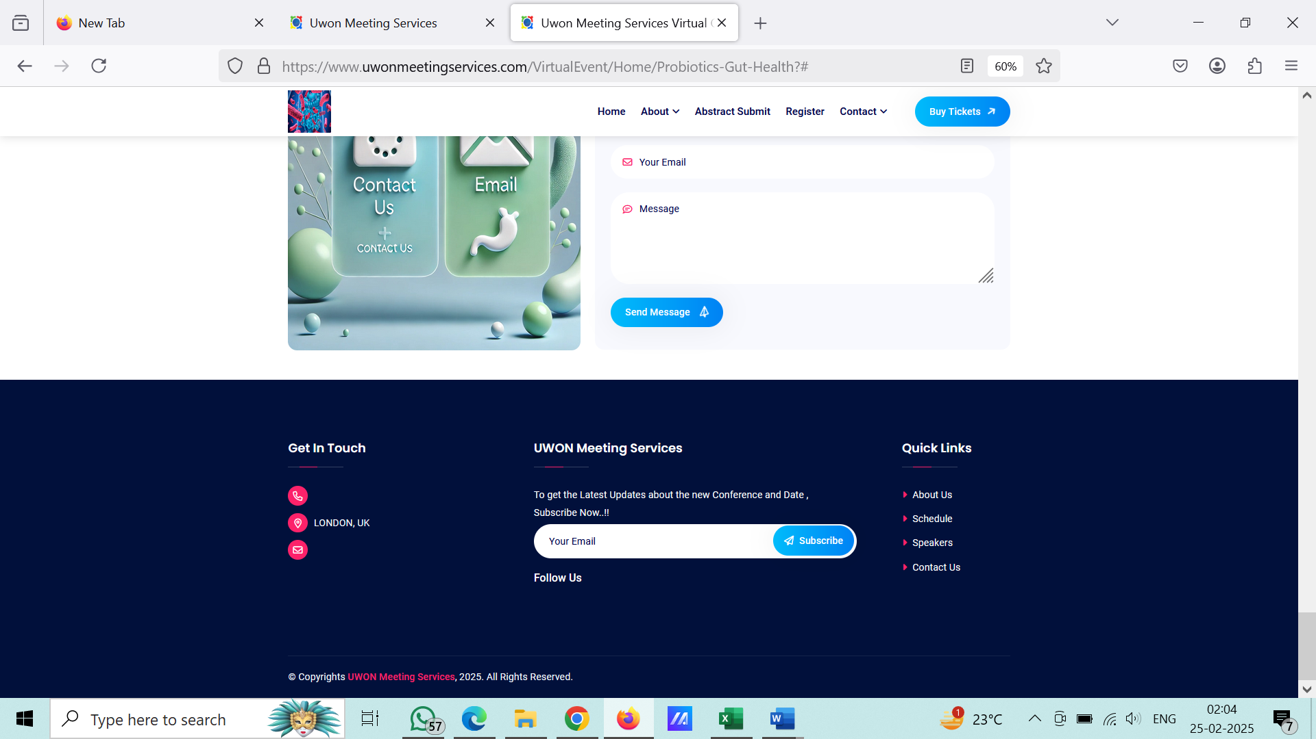

I have subscribed to the newsletter through the option at the footer. But did not get the email listed in the Subscription List at the admin panel.